**🚗 *Ever Wondered How UBER Drivers Optimize Their Rides? Here's What I Found with SQL* 💡**

I often travel with Uber, and one day during a ride, I caught myself thinking...

**"How do Uber drivers manage back-to-back rides so smoothly? Is there a way to measure how efficiently they operate? And more importantly — how does the business make this profitable?"**

As a curious data analyst, I couldn’t let the thought go.  
So I grabbed a rides dataset 📊, fired up SQL, and started digging.

Using **LEAD()**, **LAG()**, and **DENSE_RANK()**, I pulled out patterns that could offer **real-world operational insights**.

Found 3 awesome insights using SQL:

✅ Profitable Rides: ***Optimize driver dispatch logic & Reduce wait time between rides***

🔄 Round Trips:***repetitive localized demand***

📍 Frequent Pickup Zones: ***optimize driver allocation***

Here’s what I found 👇

✅ Profitable Rides: ***Optimize driver dispatch logic & Reduce wait time between rides***

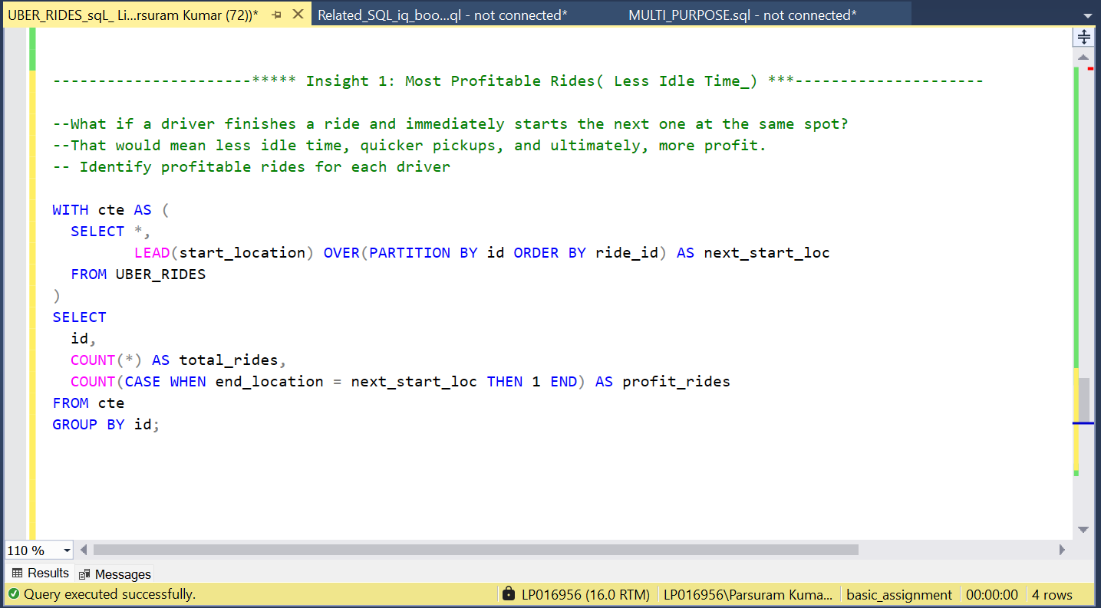

**🧠 Why it matters**:  
This can help ride-sharing platforms:

* Optimize driver dispatch logic
* Reduce wait time between rides
* Improve rider experience with faster pickups

Stay tuned — next insights cover round trips and base zones( Frequent Pick-up Zone) 🚀

🔄 Round Trips:***repetitive localized demand***

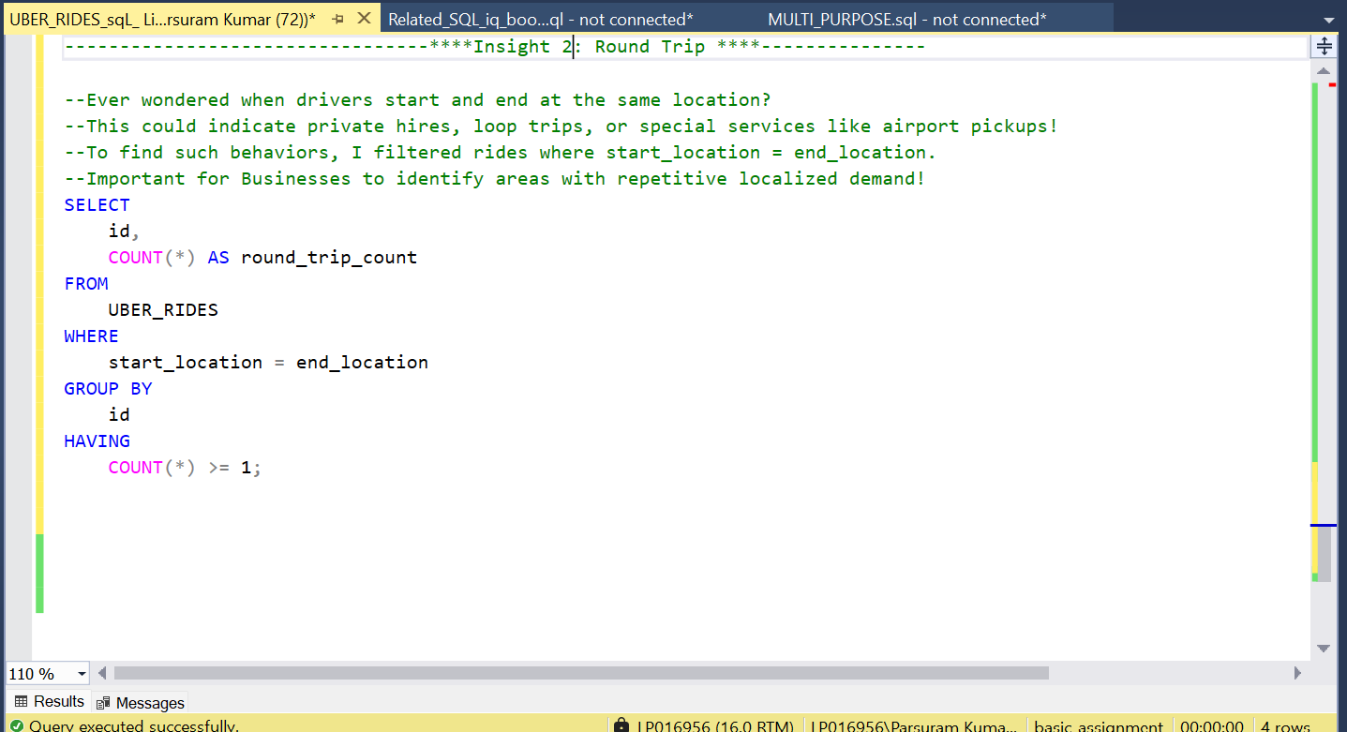

**🧠 Why it matters**:

* Drivers with high round_trip_count might be **doing local shuttles**, **return trips**, or **premium bookings**.
* Businesses can identify areas with **repetitive localized demand**!

Stay tuned — next insights cover base zones 🚀

📍 Frequent Pickup Zones: ***optimize driver allocation***

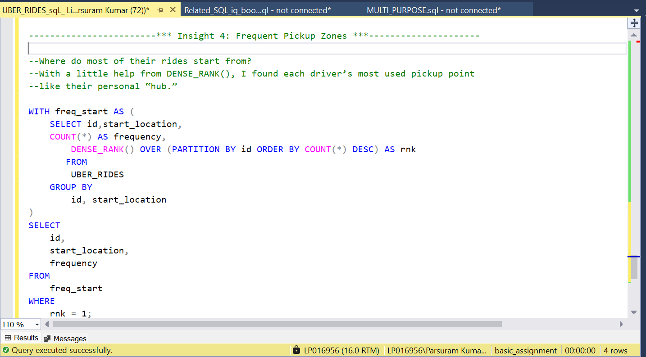

**🧠 Why it matters**:

* **start_location** = the zone where the particular driver most frequently starts rides.
* Uber Business can use this to **optimize driver allocation** or **set up marketing hotspots**!

**💭 Final Thought**

Its all started with a simple curiosity while riding in an Uber.

But it turned into a **data-driven journey** exploring how SQL can translate ride logs into smart business decisions — be it for **profit planning, driver placement, or demand analysis**.

Let me know what **you** would analyze from this data — always up for a ride through ideas! 👇

#SQL #UberData #DataStorytelling #BusinessIntelligence #LeadLag #DenseRank #AnalyticsInAction #PowerQuery #RealWorldData #DataAnalytics